GOVERNMENT OF PUERTO RICO EDUCATION DEPARMENT Register as Assistant to Federal Affairs

AFFIDAVIT

I CESAR A. GONZALEZ VELAZQUEZ, in my personal capacity or in representation of the LS Innovative Education Center; with my employer number social security 660-75-2581, adult, (profession) merchant (marital status) married, neighbor of ___ under the most solemn oath.

UNDER OATH I DECLARE THE FOLLOWING [I hereby swear as follows]:

1. That my name and other personal circumstances are those previously expressed.

2. That at the time of signing this sworn statement and during the last ten years, neither the undersigned, nor the legal entity with or without profit aims that I represent, nor any of the owners, official, shareholders, directors, agents, partners or members of the same has been convicted, has pleaded guilty, probable cause for arrest has been determined, or is aware that he is under investigation in the state or federal forum, or in any other jurisdiction of the United States of America. those crimes constituting fraud, embezzlement or illegal appropriation of public funds 1

3. That I understand and accept that the accusation or declaration of guilt for any of the crimes that constitute governmental corruption, in addition to any penalties, entails the automatic termination of all contracts between the undersigned, the legal entity with or without profit. I represent and the Department of Education of Puerto Rico (If the information is affirmative, it must specify the crimes for which it was found guilty or made the allegation of guilt).

4. That neither the undersigned, nor the legal entity with or without the profit motive that I represent, nor any of the owners, officers, shareholders, directors, agents, partners or members thereof have been convicted or declared guilty in the federal jurisdiction , in the states or territories of the United States of America or in any other country, for crimes whose elements are equivalent to bribery, fraud, illegal appropriation of public funds, undue influence or any other equivalent conduct.

5. That the undersigned, the legal entity with or without profit or some of the owners, officers, shareholders, directors, agents, partners or members are not found (check one of the above)

under investigation at any legislative, judicial or administrative procedure, whether in Puerto Rico, the United States of America or another country.

6. That the undersigned, and legal entity with or without profit that I represent, undertakes to comply with the provisions of the "Code of Ethics for Contractors, Suppliers and Applicants for Economic Incentives of the Executive Agencies of the Commonwealth of Puerto Rico. Rico ", Law Num. 84-2002, as amended, as well as with all applicable state and federal regulations and legislation.

7. That I make this sworn statement for the Department of Education of Puerto Rico, as well as any state or federal government entity, public corporation or municipality, to have knowledge of what is stated herein and for any other administrative and / or legal purpose.

AND SO THAT I CONSIDER, I swear and sign this declaration in Moca Puerto Rico on September 27, 2018

AFFIDAVIT NUMBER:
JURY AND SUBSCRIBED to CESAR A. GONZALEZ VELAZLQUEZ, of the
Personal circumstances mentioned above and who I identify through personal knowledge
_ in · Mocha, today _ of
September 2018

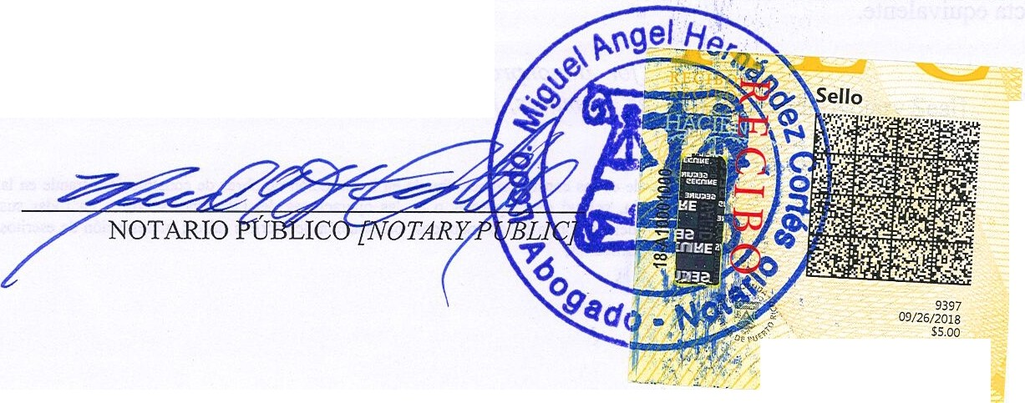
-----------'.]
Serio de Asistenda leaal
00027-2018-0926·44940120

